Learn the difference between a weak password and a strong, unique password.

1. Difference Between Weak and Strong, Unique Passwords
A password is a secret combination of characters used to protect an account, device, or system.

Weak Password vs. Strong Password
Weak password
Easy to guess
Examples:
- 123456
- password123
- prabin123
- qwerty
Weak passwords are short, predictable, or based on personal information. Attackers can guess or crack them more easily.
Strong password
Hard to guess
Example:
- River!Cloud7#Tiger92
- Mango$Train84!Forest
Strong passwords are long, unpredictable, and difficult to crack through brute-force or dictionary attacks.

Characteristics of a Strong Password
- Length: At least 14–16 characters is a good target.
- Complexity: Use a combination of uppercase letters, lowercase letters, numbers, and symbols.
- Uniqueness: Use a different password for every account.
- Unpredictability: Avoid names, birthdays, phone numbers, and common words.
- No reuse: Never reuse passwords across multiple websites.

What Does a Unique Password Mean?
Suppose you have three accounts:
Account | Password
Gmail | River!Cloud7#Tiger92
Facebook | Mango$Train84!Forest
GitHub | Blue@Mountain56#Star
Each account has a different password. If one account gets compromised, the others remain protected from password reuse attacks.

Why Are Strong Passwords Important?
- Protect accounts against brute-force attacks.
- Reduce the risk of credential stuffing.
- Prevent unauthorized access.
- Protect personal and financial information.
- Reduce damage if another website suffers a data breach.

Best Practices
- Use a password manager such as Bitwarden or KeePass.
- Enable Multi-Factor Authentication (MFA).
- Never share passwords with anyone.
- Avoid saving passwords in plain-text files.
- Use randomly generated passwords.
Remember
Strong = Long + Unpredictable
Unique = Different password for every account.
A strong password protects one account; a strong, unique password strategy helps protect all your accounts.

Why Using the Same Password on Several Websites Is Risky
Using the same password on multiple websites is dangerous because if one account gets hacked, attackers may use that password to access your other accounts.
This type of attack is called Credential Stuffing.

How Does It Work?
Imagine you use the same password for Gmail, Facebook, and GitHub.
Website A gets hacked
Your username and password are stolen.
Attacker obtains your password
The attacker collects leaked login credentials.
Attacker tries the same password elsewhere
Gmail
At risk
Facebook
At risk
GitHub
At risk

Main Risks
- Multiple account compromise: One leaked password can expose several accounts.
- Identity theft: Attackers may access your personal information.
- Financial loss: Banking or shopping accounts may be compromised.
- Privacy violations: Private messages, photos, and documents may be exposed.
- Account takeover: Attackers may change passwords and lock you out.

How to Stay Safe
- Use a different password for every website.
- Use a password manager to store passwords securely.
- Enable Multi-Factor Authentication (MFA).
- Change passwords immediately if they are exposed in a data breach.
- Never share your login credentials.

Practical Example
If your Facebook password is leaked and you use the same password for Gmail, an attacker might try those credentials on Gmail too.
Even if your Gmail account was never hacked directly, it could become compromised.
Key takeaway
Never reuse passwords. One compromised account should not give attackers access to all your other accounts.

How a Password Manager Helps Users Manage Unique Passwords
A Password Manager is a security tool that securely stores, generates, and manages passwords for different websites and applications.
Instead of remembering many passwords, users only need to remember one strong master password to access their password vault.

How Does a Password Manager Work?

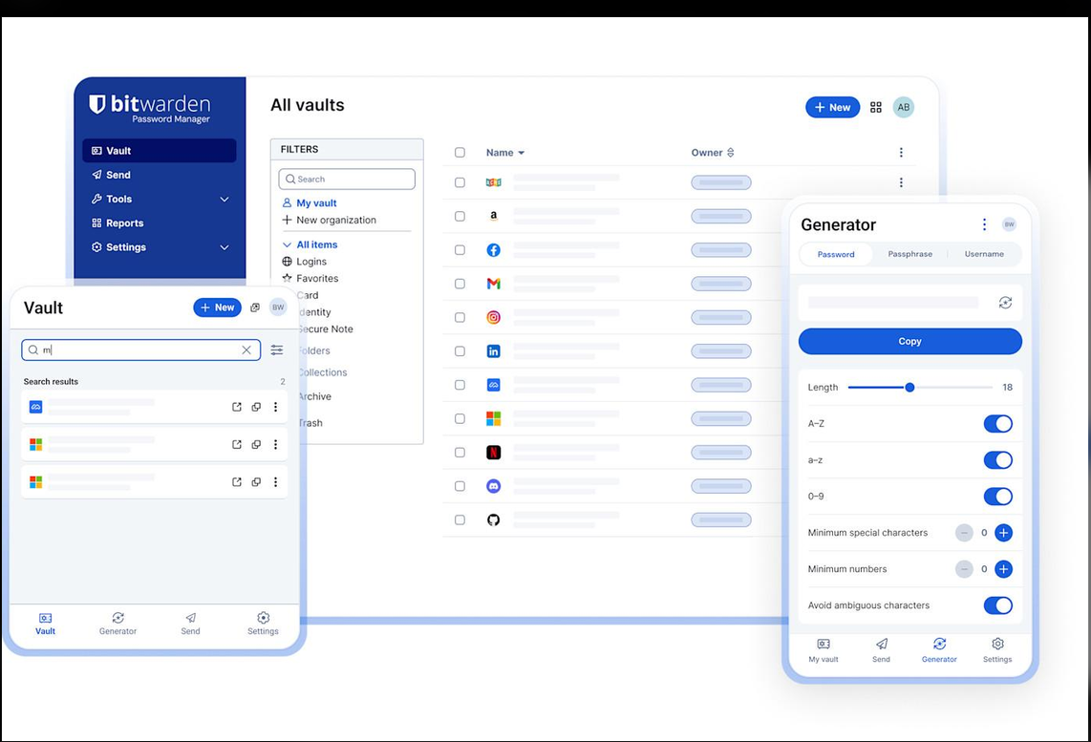
- Generate passwords: Creates strong, random passwords for different accounts.
- Store passwords: Saves login credentials in an encrypted vault.
- Auto-fill passwords: Automatically fills in usernames and passwords on websites.
- Manage accounts: Organizes passwords for different websites and applications.
- Check password security: Identifies weak, reused, or compromised passwords.

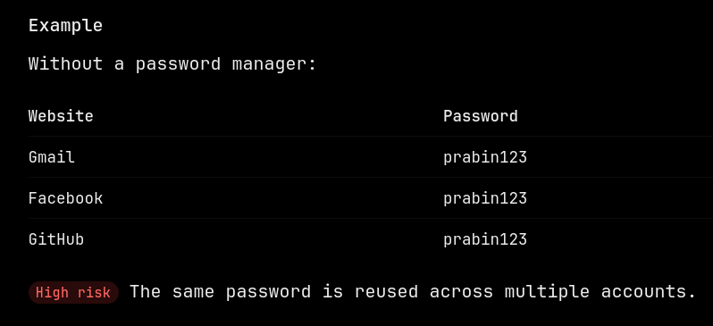
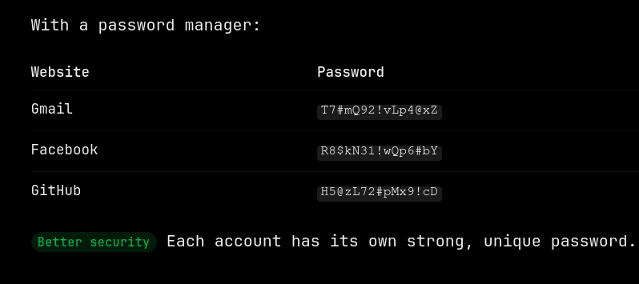

Security Benefits
- Reduces password reuse.
- Protects passwords using encryption.
- Helps create long and unpredictable passwords.
- Makes account management easier.
- Reduces the risk of credential stuffing attacks.

Important Security Tips
- Create a strong master password.
- Enable MFA on your password manager.
- Never share your master password.
- Keep your password manager updated.
- Download it only from its official website.
Key takeaway
A password manager helps users create and store strong, unique passwords for every account without having to remember them all.
Remember: One master password, many unique passwords, better security.

How MFA Provides Additional Account Protection
MFA (Multi-Factor Authentication) is a security method that requires users to provide two or more different forms of verification before accessing an account.
It adds an extra layer of security beyond a username and password.

How Does MFA Work?
Normally, when logging into an account, you only enter your username and password.
With MFA, you must complete an additional verification step.
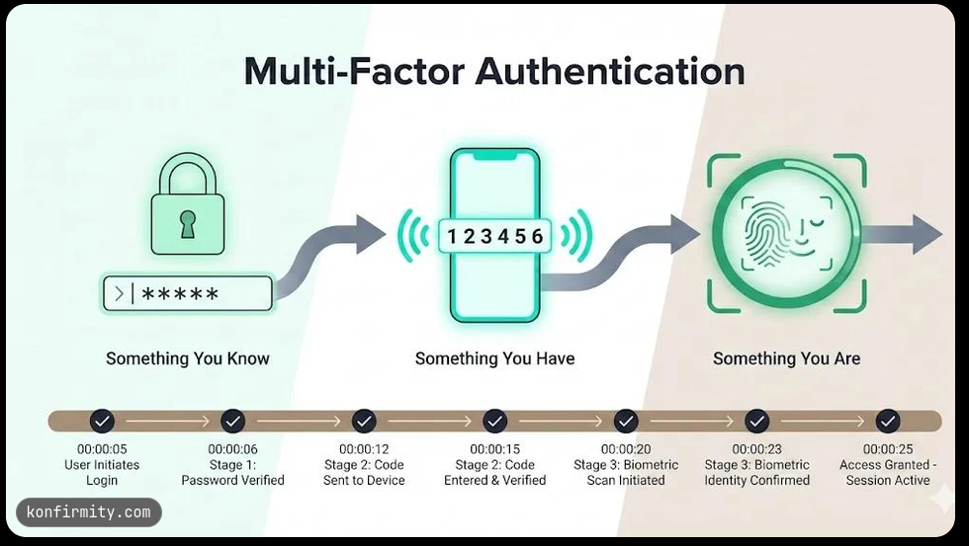
Example:
- Open your Gmail account.
- Enter your username and password.
- Google requests additional verification.
- Enter the OTP (One-Time Password) sent to your phone or generated by an authenticator app.
- After successful verification, you can access your account.
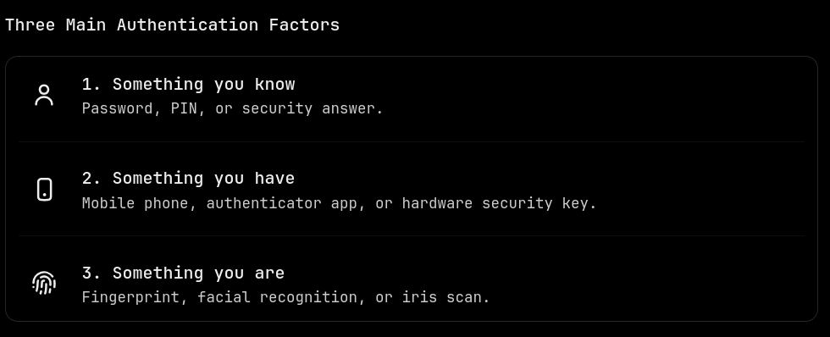

Common Types of MFA

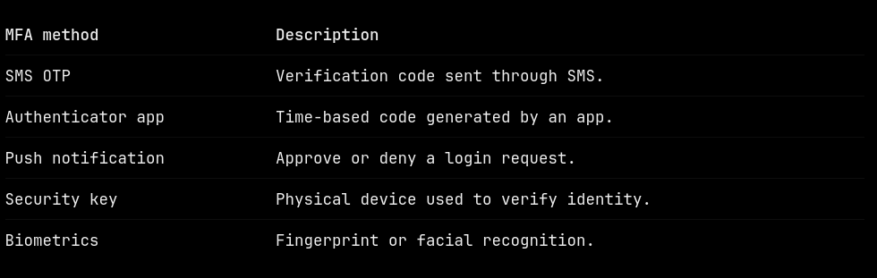

Why Is MFA Important?
Imagine an attacker discovers your Gmail password through a phishing attack.
- Without MFA: The attacker may log in using your stolen password.
- With MFA: The attacker must also pass another verification step.
Therefore, MFA makes unauthorized account access more difficult, even when a password is compromised.

Best Practices
- Enable MFA on email, banking, social media, and important accounts.
- Prefer authenticator apps or hardware security keys over SMS when available.
- Never share OTP codes with anyone.
- Keep backup recovery codes in a secure location.
- Never approve unexpected login requests.
Key takeaway
MFA = Password + Additional Verification.
MFA provides an extra layer of protection by making sure that knowing your password alone is not enough to access your account.

Student Account Security Checklist
A student account may contain personal information, academic records, assignments, emails, and other important data. Protecting these accounts is essential to prevent unauthorized access, identity theft, and data loss.
The following checklist provides practical recommendations for securing student accounts.

Security Checklist
Student security checklist
- Use a strong password with at least 14–16 characters.
- Use a different, unique password for every account.
- Use a trusted password manager to generate and store passwords.
- Enable Multi-Factor Authentication (MFA) on important accounts.
- Never share passwords or OTP verification codes with anyone.
- Avoid clicking suspicious links or opening unknown email attachments.
- Always check website URLs before entering login credentials.
- Log out after using accounts on shared or public computers.
- Avoid accessing sensitive accounts through unsecured public Wi-Fi.
- Keep your operating system, browser, and applications updated.
- Review account login activity and report suspicious access.
- Keep recovery email addresses and phone numbers up to date.
- Never save passwords on public or shared computers.
- Back up important academic documents and files regularly.

Additional Security Advice
Students should be especially careful with:
- Phishing attacks: Fake emails pretending to be from colleges, universities, or educational platforms.
- Social engineering: Attackers manipulating students into revealing passwords or personal information.
- Public computers: Forgotten sessions can allow other people to access student accounts.
- Data breaches: A compromised educational website may expose student login credentials.

Conclusion
Following these security recommendations helps students protect their online identities, academic information, and personal data.
Remember: Use strong and unique passwords, enable MFA, stay alert to phishing attacks, and regularly monitor your account activity.

